# **MODELLING THE EFFECT OF SOCIAL DISTANCING MEASURES ON THE TRANSMISSION DYNAMICS OF COVID-19**

## **INTRODUCTION**

Social Distancing Measures (SDMs) or Non-Pharmaceutical Interventions (NPIs) have played an important role in mitigating the human health impacts of the ongoing COVID-19 pandemic. These measures aim to reduce contact between individuals and break transmission chains, preventing onwards transmission of SARS-COV-2.

Despite the efficacy of these interventions, the effects of time-limited SDMs on the quantitative transmission dynamics of COVID-19 are poorly understood. Mathematical modelling can be used a tool to explore the following questions relating to COVID-19 transmission dynamics:

1. What is the impact of differing the magnitude of a SDM interventions on a COVID-19 outbreak?
2. What is the impact of differing the “trigger day” timing and length of SDMs on a COVID-19 outbreak?
3. What is the impact of these different interventions in the context of multiple, sequentially introduced SDM interventions?

In this paper, we explore the effect of differing SDM interventions, which differ with regards to how each strategy impacts the basic reproduction number (R0) over time. We also conduct a number of sensitivity analysis to explore the concept of an “optimal” parameter space, where the parameters best mitigate the peak and overall number of infections over the course of a simulated COVID-19 outbreak.

## **RESULTS**

**Analysis 1 – The Impact of 5 Different SDM Interventions on a COVID-19 Epidemic Curve**

We explore 5 social distancing measure interventions on the dynamics of a COVID-19 epidemic curve. There will be 3 rows of figures:

1. Epidemic curve – comparing curve with intervention (blue) and without intervention (transparent blue) overlaid on the same plot.
2. R0 over time – showing the effect of the social distancing measures on the model R0
3. Re over time – showing the effect of social distancing measures on the effective reproduction number over time.

[To clarify – I am working under the assumption that SDMs can affect both the R0, and by extension the Re. This is due to SDMs changing the R0 due to reductions in transmission (similar to β(t) plots we had before). We then multiply this by S(t) to obtain Re.]

Each scenario will be explained in the methods (in detail with the “real world” rationale for considering each intervention strategy) and briefly in the results section.

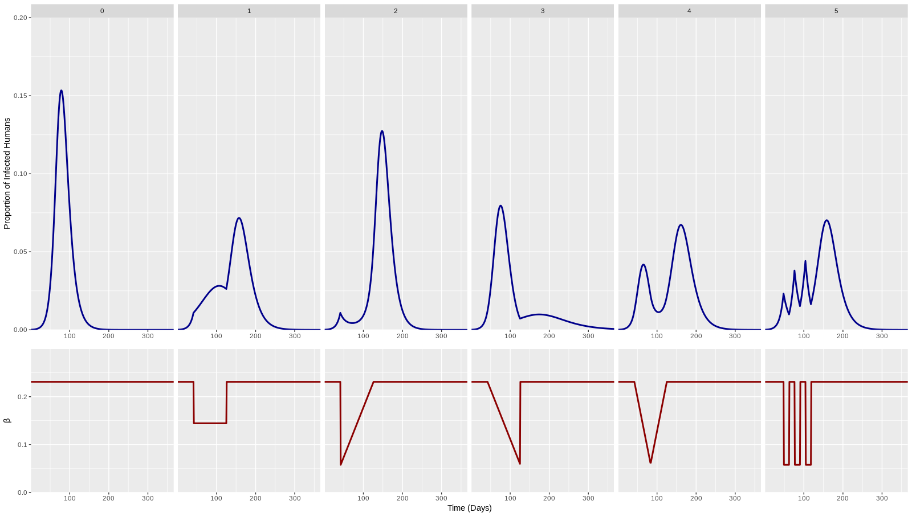

**Figure 1. Baseline + 5 scenarios for different β(t) curves – will change to R0 and add another group of plots for Re.**

The point of this section will be to show that introducing different time-limited SDMs will (somewhat obviously) have different effects on the dynamics of the COVID-19 epidemic curve.

**Analysis 2 – Sensitivity Analysis on the COVID-19 Peak Dynamics**

A sensitivity analysis was next conducted to explore the effect of changing the individual model parameters:

1. Time of Intervention Trigger
2. Length of Intervention
3. Strength of Intervention

We assess the effect of changing these parameters on two outcome measures:

1. Epidemic curve peak I(t)
2. Overall size of outbreak (cumulative incidence at the end of simulation).

This will result in a 2x3 plot grid. Each plot will have all 5 scenarios plotted/overlaid on them.

I have removed a doubling time (T2) analysis, as R0 and doubling time are intrinsically linked to produce the generation time (and gamma). So, allowing doubling time to vary while keeping R0 static will either mean gamma/generation time will have to change (due to a new T2) or gamma/generation time will remain “linked” to some previous T2 value (which has now changed due to the sensitivity analysis and is therefore not relevant). [Does that makes sense?]

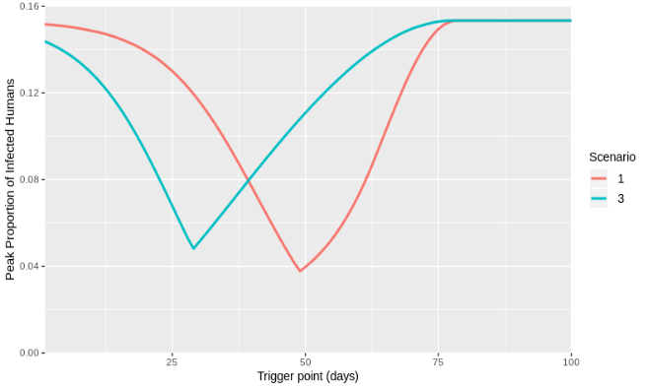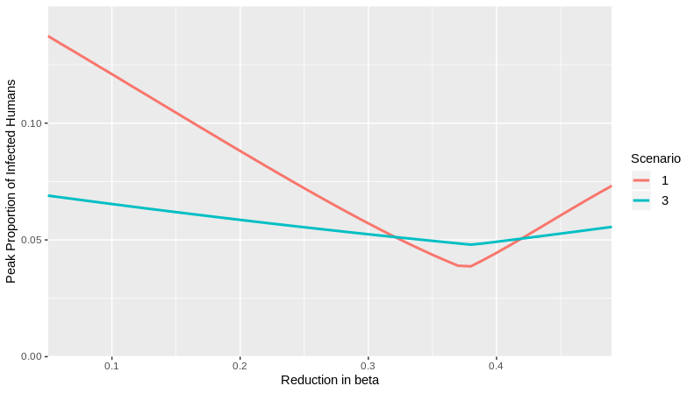

1. **Also Include a Length of Intervention analysis**

**Figure 2. Costs of being wrong: wrong timing / different R­0 / beta / T2. (line plots of tp vs. peak Inf/ final size)**

A supplementary materials analysis will also be mentioned here. We explore what is causing the “dip and increase” dynamics we observe here. This will explore only one outcome measure – the Height of the 1st and 2nd Peak and for the sensitivity analysis relating to the trigger date of the intervention. We will have 5 plots for each scenario. This will explain that the dip is due to the 1st and 2nd peak “exchanging” maximum I(t) as the trigger point changes, with both peaks being somewhat equal in the “dip” in the main figure text. With the increase on either side relating to where one peak becomes larger than the other.

This section will demonstrate that there is an “optimal” parameter space to achieve the best possible outcome for the COVID-19 epidemic curve.

**Analysis 3 - Optimising the Timing and Length of the Interventions for Peak I(t) and Cumulative Incidence.**

As identified in the analysis section 2, we identified an “optimal” parameter space for both the peak I(t) (and maybe the overall level of cumulative infection?).

To identify this optimal parameter space in higher resolution (or dimensions) we assessed the effect of both the trigger day and length of intervention on the:

1. Epidemic curve peak I(t)
2. Overall size of outbreak (cumulative incidence at the end of simulation).

We optimise all 5 scenarios for the two outcome measures in a 2x5 heatmap grid (2 columns 5 rows).

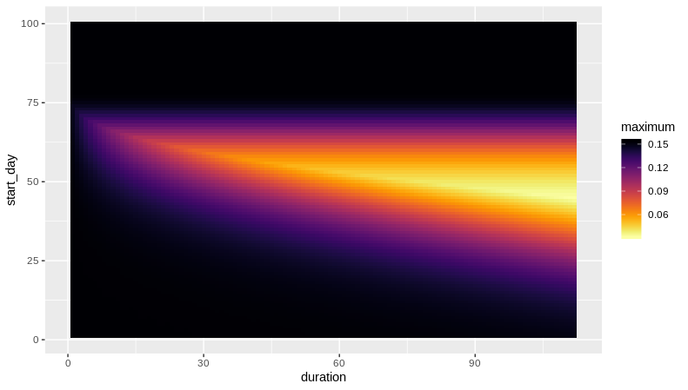

**Figure 3. Example of single plot in grid - Optimisations with respect to timing and duration (heatmap / 3D plot of peak I(t) over trigger-day & duration space).**

This section will explore this optimal parameter space in more detail and highlight the exact “optimal” location while considering multiple parameters. We also highlight that this space is often small and varying for different intervention scenarios (thin or small “bright” area on heatmap).

**Analysis 4 - Optimising the Timing and Length of Multiple Interventions for Peak I(t) and Cumulative Incidence.**

We were next interested in exploring the optimal parameter space for repeated interventions. Using the single constant intervention as an example (scenario 1), we explore a combined parameter space for:

1. Trigger date for Intervention 1 (in plot x-axis)
2. Trigger date for intervention 2 (in plot y-axis)
3. Length of intervention 1 (on grid left-to-right)
4. Length of intervention 2 (on grid top-to-bottom)

These were explored in relation to the optimal parameter space needed for the lowest possible COVID-19 epidemic peak.

We will achieve this by having a 3x3 grid of the below plot (length for intervention 1 and 2 will be standardised as 3 weeks, 6 weeks 9 weeks for the grid for example):

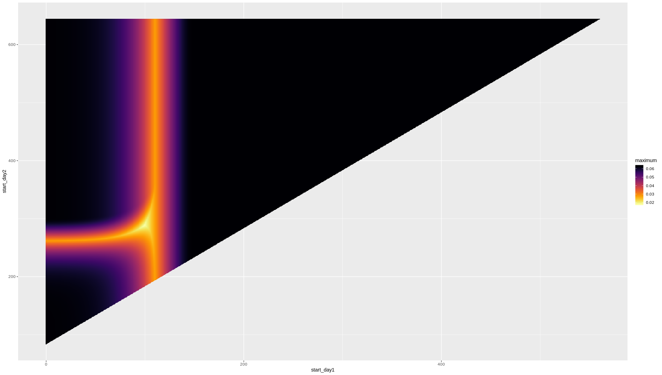

**Figure 4. Multiple interventions. Optimising for 2 trigger points and 2 durations. Heatmap for trigger points and for durations. Think about combined 4D plot. Multiple heat maps.**

With length of intervention 1 from left to right on the grid, and length of intervention 2 going from top to bottom. We will show this only for scenario 1, but also do this for all other scenarios and put the resulting plots in the supplementary material.

The point of this section is to demonstrate the concept of an “optimal” parameter space when thinking about multiple interventions. This is particularly relevant in the context of repeated lockdown being considered as a policy option in the future.

## **DISCUSSION**

**Points for discussion**

1. What are the differences between strategies (the resulting epidemic curve) for the RWC parameter set that we’ve chosen?
   1. Describe peak dynamics and the cumulative incidence differences.
   2. What happens when we start exploring the parameter space (the “best” one was due to (accidentally) hitting the epidemic at the right time) – Justifies the use of a sensitivity analysis (not just using one parameter set).
2. Maybe mention the concept of peak dynamics – often interventions are thought to push back the epidemic curve – but here we demonstrate that if it takes too long to ramp up the intervention, the 1st epidemic curve still occurs (earlier – Intervention 4) and the 2nd peak is supressed.
3. Describe the concept of being “wrong” for the timing, length or strength of an intervention – (the increases either side of the “dip and increase” dynamics).
4. Explain the concept of a small “optimum” and that in reality this will be much harder to achieve in practice.
5. It is much better to aim for an intervention which gives you a “wider” room for error – not a sharp decrease in Figure 2.
   1. What intervention is the best for this?
6. Describe the real-life parallels of the 5 strategies? Are they all actually viable in practice?

**Caveats**

1. Obviously a VERY simple model, does not describe age heterogeneity or super spreading or anything like that (Gomes paper).
2. If we don’t use a SEIR - talk about in real life there is a delay between the intervention and the effect on the epidemic curve
3. Very difficult to assign a quantitative number to the “magnitude of any intervention
4. Only considers lifelong immunity
5. Downsides to not “parameterising” the model with data
6. No deaths in the models
7. We do NOT aim to predict anything – this looks at the dynamics of social distancing measures. We do not consider that the effect of any other intervention (contact tracing) which may prevent an increase in cases after the cessation of social distancing measures.

**Additional Points**

Interesting to place this study in the context of not just deliberate differences in intervention strategies, but also the effect of human behaviour. An intervention such as lockdown might aim for a constant reduction in transmission. But human behaviour over time (lockdown fatigue) might cause a constant reduction to slowly creep and become less effective. You essentially transform one intervention scenario into another.

This analysis is probably applicable to any immunising human-to-human transmittable viral infection.

## **METHODS**

**Suggestions**

* SEIR not SIR model – not much added complexity – would reduce questions of why haven’t you adopted the framework which the vast majority of COVID-19 models have used? Would allow us to model a realistic delay
  + Likely 0 effect on model dynamics but added layer of realism
* Model fitting to data to obtain parameters – RWC is sketchy and it might be a bit odd to put – “obtained from SPI-M” as a reference (not very transparent).

**Parameters – As I understand them**

**Doubling Time** – 3.3 Days

**R0** – 2.8 (unmitigated) to calculate gamma

**R0** – 1.7 (mitigated due to other measures) – the pre and post lockdown R0.

**Magnitude of intervention** – R0 reduced to 0.8 during intervention

**Length of Intervention (Baseline)** – 6 or 12 weeks?

**Trigger Day** – 71 Days (I(t) = 0.0277)?

Or should we change approach like we did with the most recent select committee model? Stick with an R0 of 2.8 (not 1.7) throughout the pre/post-intervention phase and scale back the trigger date to obtain I(t) = 0.0277 at the trigger date?

**EVERYTHING BELOW THIS POINT NEEDS CHANGING – FROM ORIGINAL DOC**

**Model**

A SIR model without demography was implemented to explore the effects of time-limited social distancing measures (SDM) on a hypothetical outbreak scenario (eqn 1.1). We assume that S, I and R compartments represent the proportion of the population that is susceptible, infectious or recovered respectively.

$$\frac{dS}{dt}=-β(t)SI$$

$$\frac{dI}{dt}=β(t)-µI$$

$$\frac{dR}{dt}=µI$$

eqn 1.1

Individuals in compartment S become infected and move into the I compartment with the time-varying rate β(t), which represents the daily per capita rate of transmission under the assumption of random mixing of the population. The daily per capita rate of recovery, μ, was assumed to be a function (reciprocal) of the average duration of infectiousness or the generation time, assuming a negligible latency period.

Using an epidemic doubling time (T2) of six days and basic reproduction number (R0) of two, the generation time (G) or average duration of infectiousness (1/μ) was calculated to be 8.62 days using eqn 1.2. The reciprocal of the generation time (μ) and a baseline R0 of 2 was used in eqn 1.3 to obtain baseline β(t) and μ values of 0.231 and 0.116 respectively.

$$Generation Time (G)=T_{2}\frac{\left(R_{0}-1\right)}{ln⁡(2)}$$

eqn 1.2

$$R_{0}=\frac{β}{µ}$$

eqn 1.3

Time-limited SDMs were modelled through reductions to the β(t) parameter, with these interventions differing based on the temporal distribution of the β(t) reductions. We explored six different scenarios, each lasting for 12 weeks (84 days) and with identical magnitudes of β(t) reductions over the 12-week period (Table 1). All SDM interventions were initiated at day 41 (I(t) = 0.01). All models were initiated with the following initial conditions: S = 0.9999, I = 0.0001, R = 0. All simulated outbreaks were run for 365 days.

**Table 1** – Description of the six different SDM intervention scenarios.

|  |  |  |
| --- | --- | --- |
| Scenario | Description | Beta over 12 Weeks |
| 1 | No SDMs. |  |
| 2 | Constant 0.625*β(t) reduction.  (Min β(t) = 0.144) |  |
| 3 | Immediate 0.25*β(t) reduction followed by a linear increase back to baseline β(t).  (Min β(t) = 0.058) |  |
| 4 | Linear decrease to 0.25*β(t) followed by an immediate return to baseline β(t).  (Min β(t) = 0.058) |  |
| 5 | Linear decrease to 0.25*β(t) at week 6, followed by a linear increase back to baseline β(t).  (Min β(t) = 0.058) |  |
| 6 | A “pulsing” SDM with 0.25*β(t) reductions between weeks 1-3, 5-7 and 9-11.  (Min β(t) = 0.058) |  |

Three summary statistics were used to explore the efficacy of each SDM intervention: 1) Total fraction of infected individuals (i.e. outbreak size), timing of the epidemic peak and the fraction of infected individuals at the epidemic peak (peak incidence).

All model simulations were carried out using R (v3.6.2) and C++. The “desolve” package was used for all R based simulations.

Further updating to include description of methods for figures in results

Perhaps fit to data to get the initial parameters for r0 etc